Screenshot 1: Downloaded and extracted the package

Screenshot 2: Note: there is no available option to modify the amount of RAM used. This is version 4.25

Screenshot 3: Created the file .wslconfig with the attached script inside of it

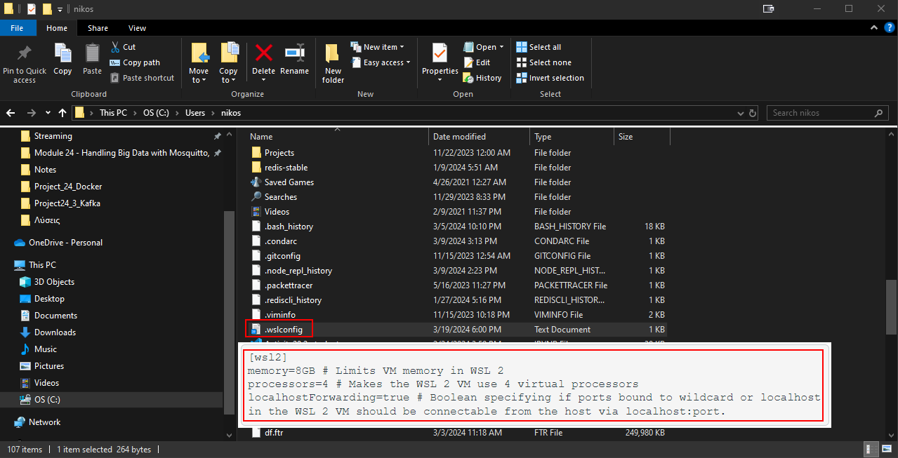

Screenshot 4: All containers running on docker after executing docker compose up

Screenshot 5: Confluent web page is available

Screenshot 6: Showing the default topics

Screenshot 7: Created a new topic called *vehicle-coordinates*, with 1 partition

Screenshot 8: Ran pip install kafka-python

Screenshot 9: Code for producing vehicle coordinates

Screenshot 10: Setting topic name, longitude, and latitude variables

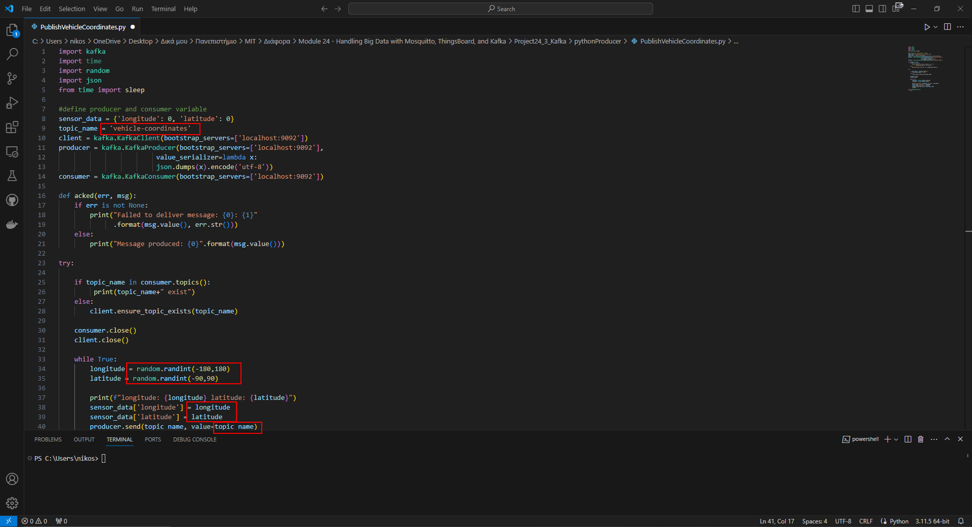

Screenshot 11: Running the code, capturing longitude and latitude values

Screenshot 12: Verifying node.js existence by checking version

Screenshot 13: set the input button to say “Consume Vehicle Coordinates”, and assigned the topic to the one created earlier on Kafka

Screenshot 14: started the server.js server

Screenshot 15: Accessing the server through the web

Screenshot 16: Successfully consumed the vehicle coordinates

